

SYMBIOSIS INTERNATIONAL (DEEMED UNIVERSITY)
(Established under section 3 of the UGC Act 1956)
Re-accredited by NAAC with “A” Grade

Name of the Student: Sneha Sah PRN: 25070122189
Semester: 3 Year: AY 25-29

ASSIGNMENT No: 15

TITLE: Write a Java program to demonstrate exception handling using finally, throw, and throws.
Problem Statement: Write a Java program to demonstrate exception handling using finally, throw, and throws.
Theory:
The finally block always executes regardless of whether an exception occurs, making it suitable for resource cleanup. The throw keyword explicitly generates an exception, while throws declares exceptions that a method may pass to its caller. These mechanisms improve structured error handling and application stability.

Exercise
1. Create a Login program that throws an exception for invalid password and uses finally block.
Source code:
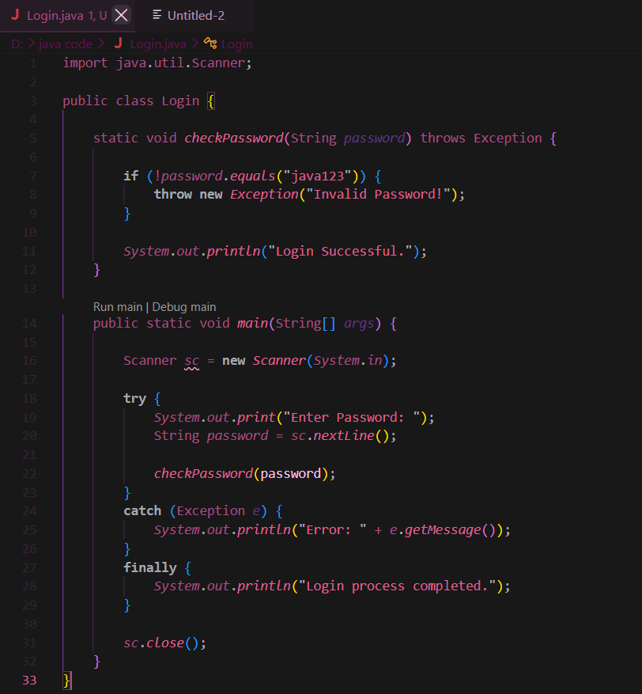
Output:
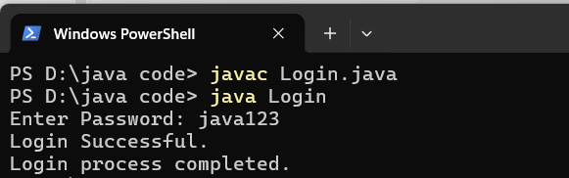

2. Create an ATM PIN Verification program that throws an exception for an invalid PIN entered by the user and uses a finally block to display a message indicating that the verification process has completed.

Source code:

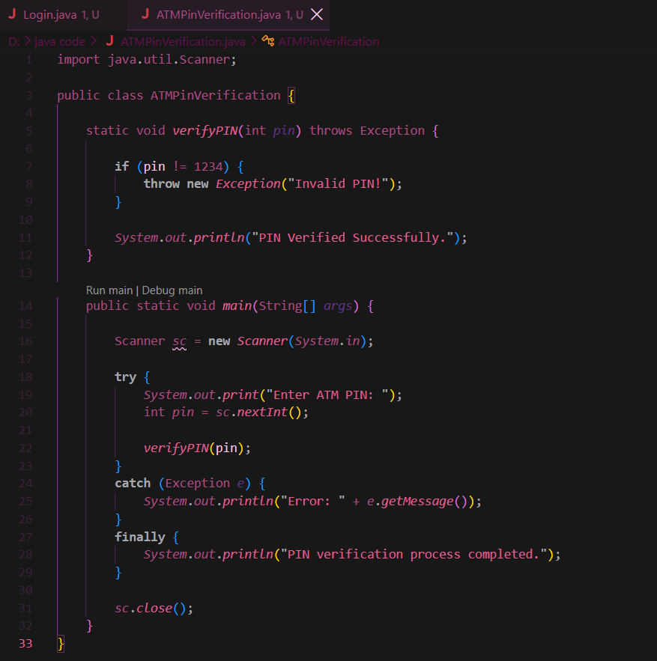

Output:

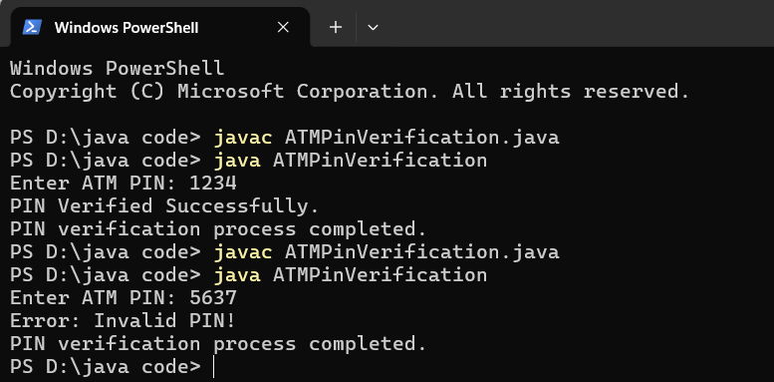

Conclusion

Thus, the experiment was successfully completed using the throw, throws, and finally keywords in Java. The throw keyword was used to generate exceptions for invalid passwords and PINs, throws was used to declare exceptions in methods, and the finally block was used to display a completion message regardless of whether an exception occurred.

